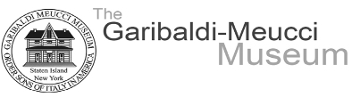
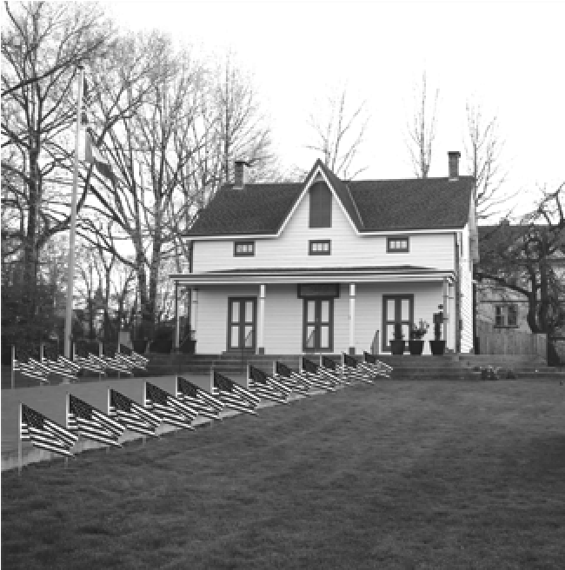


July 12, 2023

Dear Friends,

We are proud to announce that the Garibaldi-Meucci Museum is again planning a patriotic display of
U.S. Flags to be placed on the front lawn of the Museum, located at 420 Tompkins Ave., Staten Island,
NY. The display will run from October 23rd – November 23rd, 2023 and will be in place during the
annual Garibaldi-Meucci Museum Fundraiser Luncheon on November 11th. The U.S. Flags measure
12”x 18”, consist of 6 lines with up to 5 words per line, and will be placed across a field of green.

Join us in celebrating and honoring the patriotism of all those who have through the ages made the United States
of America the greatest nation in the world. We will also pay tribute to the 19th century Italian patriot and military leader,
General Giuseppe Garibaldi, who crusaded for a unified Italy.

You can sponsor a U.S. Flag(s), either in honor of or in memory of, a loved one for $20.00 per Flag. Each Flag comes with
a tag detailing the honoree and the sponsor. The display of U.S. Flags can also serve to honor an active member of the
military, a personal hero, a first responder, such as a police officer or a fire fighter. Become a proud sponsor of this event
by mailing the Flag Order Form below with a check payable to the Garibaldi-Meucci Museum to Anthony Capriola,
191 Loring Road, Levittown, NY 11756. Anthony can be reached at (516) 390-7199 or e-mail tonyjo7674@yahoo.com with
any questions. Your contribution is tax deductible.

Thank you for supporting the Garibaldi-Meucci Museum in this initiative, while remembering and honoring the many heroes who have served to protect us.

-----------------------------------------------------------------------------------------------------------

FLAG ORDER FORM (please return by September 1, 2023)

First Name __________________________________Last Name__________________________________________

Address_____________________________________City_________________________State_______ Zip________

Email Address________________________________________Phone_____________________________________

Please indicate how many Flags you would like to order @ $20 per Flag: ____________

Name(s) of the individual(s) you are honoring (use reverse side to indicate additional names and information):

__________________________________________________________________________________________

Indicate if the Flag is in Honor of or in Memory of the individual:_____________________________________

Branch of Military, Rank, Years of Service, War/Campaign Served, Service Agency (police, firefighter, etc.):

___________________________________________________________________________________________

Please let this person know that I have purchased a Flag to honor their family member (use reverse side to indicate additional names and information):

Name__________________________________Address_______________________________________________

City______________________________________State__________________Zip________________



