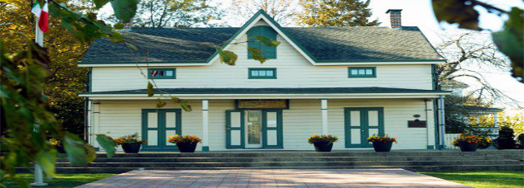
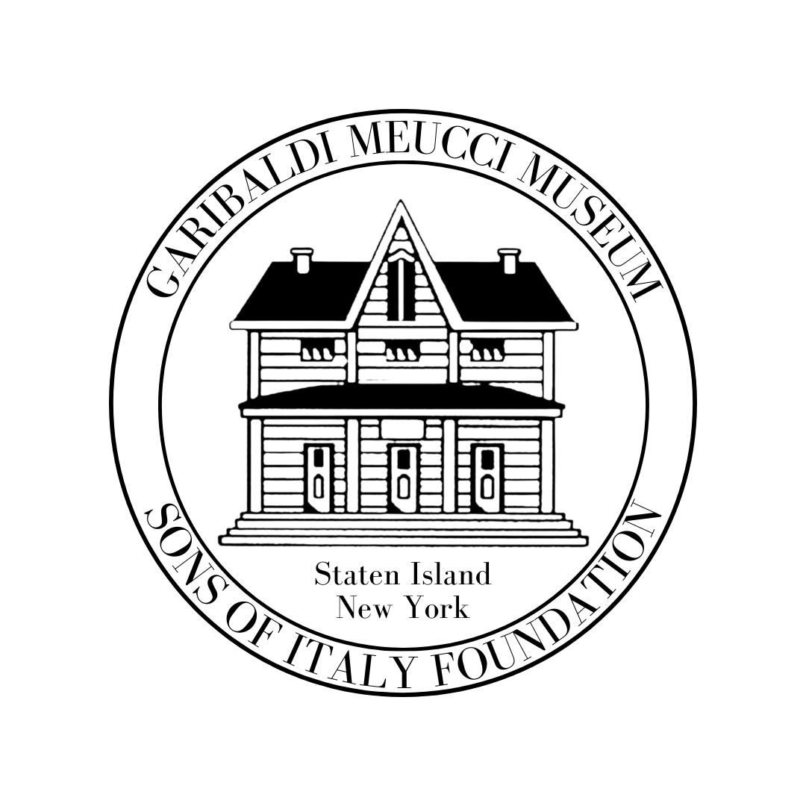
THE GARIBALDI-MEUCCI MUSEUM
420 Tompkins Ave. Staten Island NY 10305 Tel: (718) 442-1608 Fax (718) 442-8635
info@garibaldimeuccimuseum.org http://www.garibaldimeuccimuseum.com

Italian Language Courses Spring 2024 Semester
Have You Been Thinking About Learning Italian? Benvenuti!
Learn Italian at one of the oldest Italian American Cultural Centers in the
United States, the home of Antonio Meucci and his house guest
Giuseppe Garibaldi.
For your safety we follow all updated NYC CDC Guidelines
The museum is wheelchair accessible to its grounds and first floor.

10 Week Spring Semester Classes Begins in February 2024
Italian Language Level I Class: Diane De Bernardo
Time 12:30 p.m. – 2:00 p.m. Starting Monday February 26th
This class is the very beginning of learning the language. You will learn some fun and useful phrases and practical vocabulary to begin speaking Italian. No Class April 1ST for Easter Week.

Italian Language Level II Class: Diane De Bernardo
Time: 2:30 a.m. - 4:00 p.m. Starting Monday February 26th
This course offer you the opportunity to build and expand your prior knowledge, thru the study of topical vocabulary and grammar. Thru interactive activities you will gain the confidence to speak La Bella Lingua Class April 1ST for Easter Week.

Italian Language Level III: Class: Rose Frisari
THIS CLASS IS FULL/CALL THE MUSEUM TO BE PLACED ON A WAITING LIST
Time: 11:30 a.m. – 1:00 p.m. Starting Tuesday February 27th This class is designed for students who have had one or more years of study in Italian and are interested in expanding their knowledge of the language. We dedicate more time to listening, speaking, reading and writing, so we can learn to master la Bella lingua. No Class April 2nd, for Easter Week.

Advanced Italian Class: Bartolomeo Regine
Time 5:00 p.m. - 6:30 p.m. Starting Monday February 26th
This class is designed for students who have a good proficiency of Italian and wish to expand their
knowledge of the language. Conducted entirely in Italian.
$225 for Non-Members/$210 Museum Members (Must Be Paid in Advance)
(90-minute classes) Each Class must have 10 Students

---------------------------------------------------------------------------------------------------------------------------------------------------------
Registration Form/For More Info or to Pay by Credit Card
Call 718-442-1608
Name:_______________________________________________________
Address: _____________________________________________________
Email_______________________________________________________
Home Phone: ___________________ (Cell Phone) ___________________
Manner of Payment: Check ______ Credit Card_______
Number_____________________________________________________

Security Code: __________________ Exp. Date: _____________________

Make Checks Payable To: Garibaldi-Meucci Museum
420 Tompkins Avenue, Staten Island, New York 10305
CIRCLE CLASS YOU WISH TO REGISTER FOR.

Italian Language Level I Class
Diane De Bernardo
Italian Language Level II Class Diane De Bernardo
Italian Language Level III Class
Rose Frisari
CLASS FULL
Advance Italian Conducted Entirely in Italian
Bartolomeo Regine

At this time, we are not listing Virtual Italian Classes. If you are interested in a Virtual Level I Italian Language Class on a Tuesday Evening or a Level II on a Wednesday Evening, Please Call the Museum at 718-442-1608.
or

