
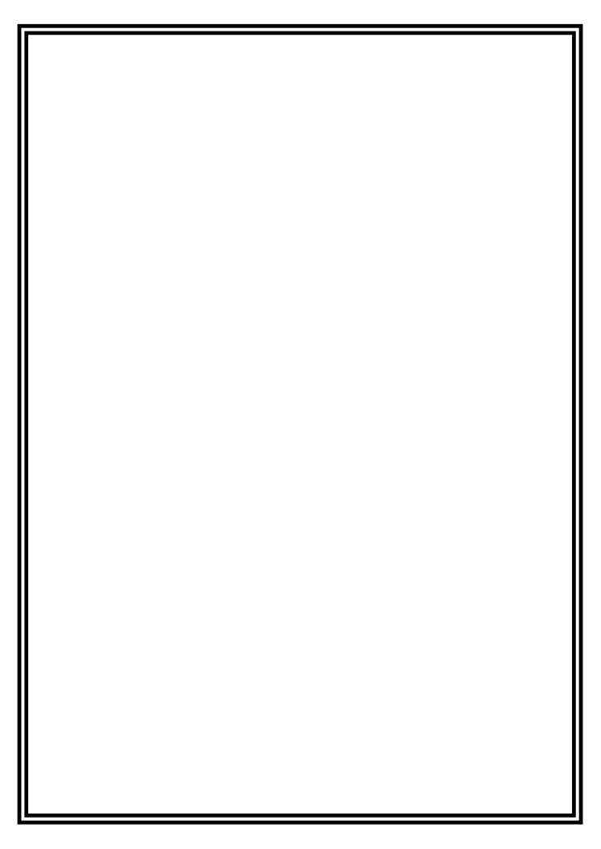
“Engrave Your Name in the History
of the
Garibaldi-Meucci Museum”

ENGRAVED BRICK ORDER FORM

Each personalized engraved brick will become part of the permanent walkway to the museum.
To order your engraved brick please completely fill out the form below:
Part 1 - Ordering information details
Part 2 - Brick inscription lettering layout.

Part 1 - ordering information details

Brick:
- $100 4x8 inch brick
- $250 8x8 inch brick
- $1,000 12x12 inch brick

Brick Order being made by:

Name: _________________________________________________ Phone: __________________

Address: ___________________________________________ State: ______ Zip code: _________

City: ______________________________________ Email: ________________________________

Please, let this person know that I have purchased the brick to honor their name or family member:
Please check one:
This brick was purchased: In Memory of: ______ or In Honor of: ______

Name: _________________________________________________ Phone: __________________

Address: ___________________________________________ State: ______ Zip code: _________

City: ______________________________________ Email: ________________________________

- My check is enclosed (Make checks payable to: Garibaldi-Meucci Museum)

- I prefer to make a Credit Card Payment:

Name on Card: ________________________________________ Type of card: _______________
Card #: ______________________________________ Exp Date: _________ 3-digit Code: ______

*** Your brick purchase is fully tax-deductible ***
Part 2 - Brick inscription lettering layout

Follow instructions and letter limit to the size specifications that you are ordering.
ONLY 1 LETTER, SPACE AND/OR PUNCTUATION PER BOX.

To be assured of your satisfaction with engraving, we ask that you fill out the grid below with the wording you wish to have inscribed onto your donated brick. SPACING RULES WILL BE STRICTLY ADHERED TO

Example of layout:
M R . J O E S M I T HS
M | R | . |  | J | O | E |  | S | M | I | T | H | S
 | ( | 1 | 9 | 2 | 1 | - | 2 | 0 | 0 | 8 | )

A 4x8” brick ($100) allows a maximum of two lines, each line containing a max of 16 characters including spaces and punctuation. Please enter your name or message in the boxes below:

1st line
2nd line

An 8x8” brick ($250) allows a maximum of four lines, each line containing a max of 16 characters including spaces and punctuation. Please enter your name or message in the boxes below:

1st line
2nd line
3rd line
4th line

A 12x12” brick ($1,000) allows a maximum of six lines, each line containing a max of 23 characters including spaces and punctuation. Please enter your name or message in the boxes below:

1st line
2nd line
3rd line
4th line
5th line
6th line

DATE: _________________ Signature: ________________________________________________________
Note: Return this form with appropriate check for size of brick to be ordered, and remit to::
Garibaldi-Meucci Museum, 420 Tompkins Avenue, Staten Island, New York 10305
Revised 2023

